## If there are suspicions of kerning (e.g. copy and paste, etc.), you will get an F grade regardless of any reasons and excuses.

1. Summarize chapters from Ch. 7.6 to Ch. 7.7 in the text book.

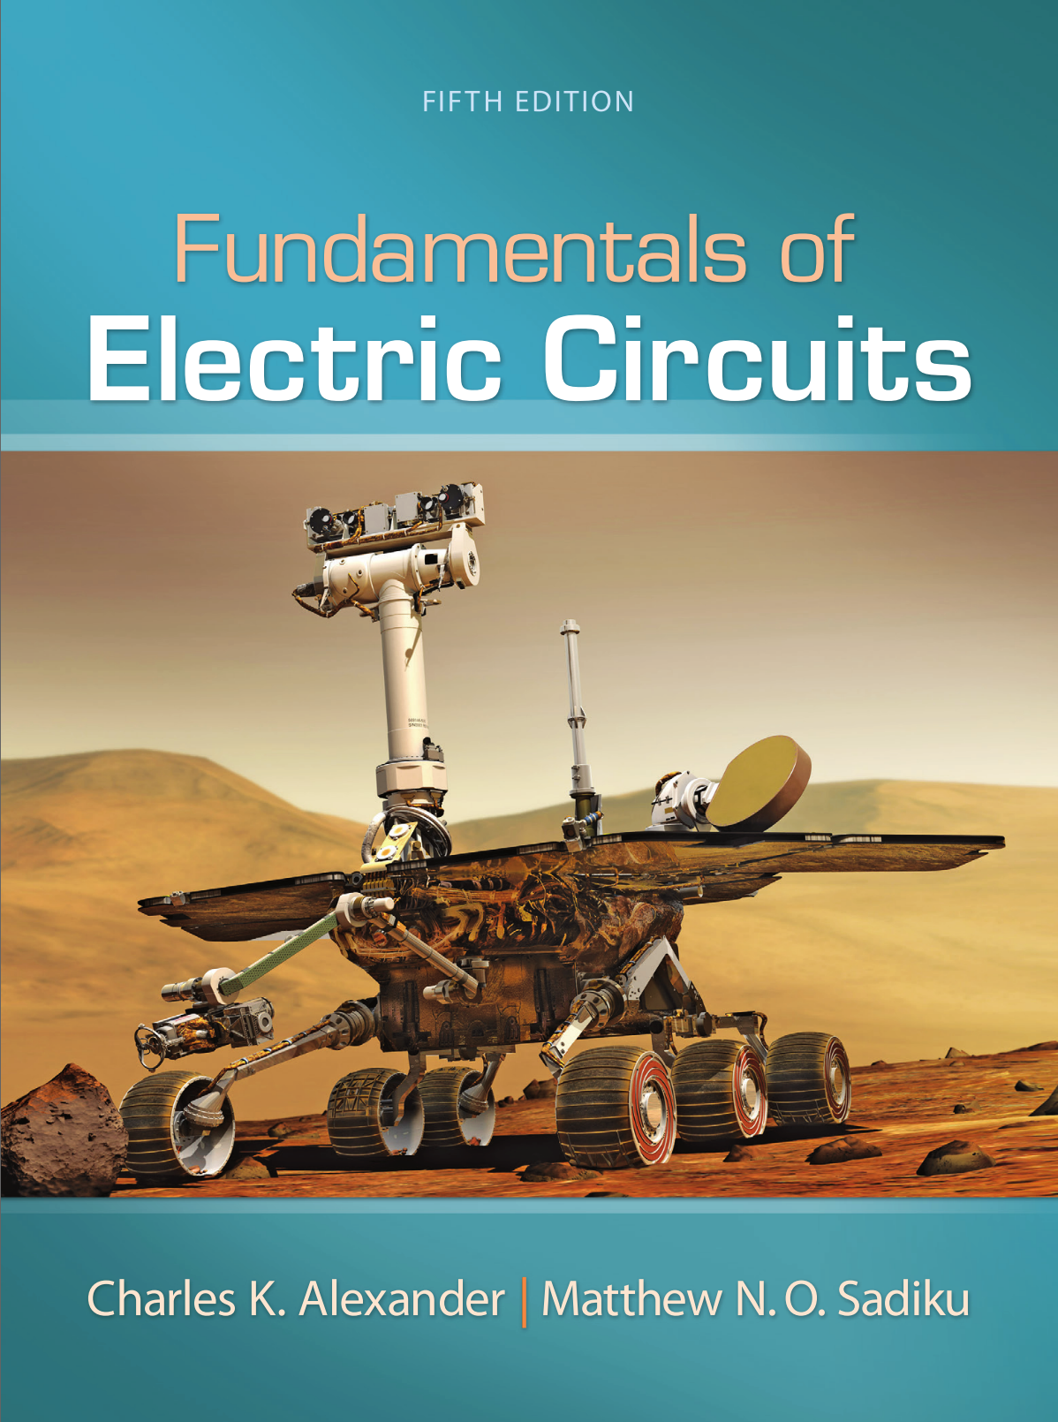

1. Please describe the solution of the examples in Chapter 7.6 and Chapter 7.7 by handwriting. And take a picture of the solutions and attach the picture to the assignment file.